**HANDWRITTEN DIGIT RECOGNITION**

**TABLE OF CONTENTS**

|  |  |  |
| --- | --- | --- |
| **S.NO** | **TITLE** | **PAGE** |
| 1 | Introduction | 3 |
| 1.1 | Project Overview | 3 |
| 1.2 | Purpose | 3 |
| 2 | Literature Survey | 4 |
| 2.1 | Existing problem | 4 |
| 2.2 | References | 4 |
| 2.3 | Problem Statement | 5 |
| 3 | Ideation & Proposed Solution | 6 |
| 3.1 | Empathy Map canvas | 6 |
| 3.2 | Ideation & Brainstorming | 6 |
| 3.3 | Proposed Solution | 7 |
| 3.4 | Problem Solution Fit | 8 |
| 4 | Requirement Analysis | 8 |
| 4.1 | Functional Requirement | 8 |
| 4.2 | Non-functional Requirement | 9 |
| 5 | Project Design | 9 |
| 5.1 | Data Flow Diagrams | 9 |
| 5.2 | Solution &Technical Architecture | 10 |
| 5.3 | User Stories | 13 |
| 6 | Project Planning & Scheduling | 14 |
| 6.1 | Sprint Planning & Estimation | 14 |
| 6.2 | Sprint Delivery Schedule | 15 |
| 6.3 | Reports from JIRA | 15 |
| 7 | Coding & Solutioning | 16 |
| 7.1 | Feature-1 | 16 |
| 7.2 | Feature-2 | 16 |
| 8 | Testing | 16 |
| 8.1 | Test Cases | 16 |
| 8.2 | User Acceptance Testing | 17 |
| 9 | Results | 18 |
| 9.1 | Performance Metrics | 18 |
| 10 | Advantages & Disadvantages | 18 |
| 11 | Conclusion | 19 |
| 12 | Future Scope | 19 |
| 13 | Appendix | 20 |
|  | Source Code | 20 |
|  | GitHub & Project Demo Link | 28 |

**1. INTRODUCTION**

**1.1. PROJECT OVERVIEW**

Traditional methods of recognising handwriting rely heavily on a lot of prior knowledge like Optical Character Recognition (OCR). Since the style of handwriting changes with every individual, it is a challenging task in identifying the characters correctly. The thickness of stroke, style carries uniqueness with different person depending on them. The rapid growth in the need for digitizing handwritten data and the availability of massive processing power demands improvement in recognition accuracy. Hence a highly proficient algorithm is required when dealing with handwriting recognition. Handwritten digit recognition can be done using deep learning methods effectively. The Convolutional Neural Networks (CNN) is a deep learning algorithm that is highly suitable for image recognition and those tasks involving processing of pixel data. MNIST data set is widely used for this recognition process and it has 70000 handwritten digits. Those images are split as train set and test set images. Artificial neural networks is used to train these images and build a deep learning model. Web application is created where the user can upload an image of a handwritten digit. this image is analysed by the model and the detected result is returned on to UI.

**1.2. PURPOSE**

Each individual has a unique handwriting style which makes it a bit complex to identify the digits. If the handwritten digit recognition becomes an efficient practice, this will help digitize number processing. Huge amounts of data can be processed by machine which will save loads of time. In today’s world, technology plays a major role in handling data, therefore it is important to bring this system in managing data. Workers at the postal office sorting throughs mails using the postal code can be helped using this. This also comes handy while arranging records and huge amounts of information. Manual labour is eased and it saves up a lot of time. It can be used in programming checks and in case of tax documentation. The labour cost will also be reduced with the help of machines. There are also the activities of processing bank checks and tax documentations. Large piles of records and archives can be arranged and sorted well easing the stress and work load from manual labourers.

**2. LITERATURE SURVEY**

**2.1. EXISTING PROBLEM**

Because of the progress in science and technology everything is being digitalised to reduce human effort. It takes a lot of time and effort on the side of manual workers when sorting through mails by postal codes. It is not an easy task to handle data by human worker. There is also the possibility of human error while processing huge amount of data. Therefore, digitizing these will help reduce time and labour. The labour cost will also be reduced with the help of machines. There are also the activities of processing bank checks and tax documentations. Large piles of records and archives can be arranged and sorted well easing the stress and work load from manual labourers. The problem with handwriting is that every individual has different style of writing. There is a differing thickness of stroke, style and general uniqueness that just brings a level of hardness in identifying the handwriting. The machine must be capable of picking up the digits correctly with a good accuracy rate. Hence a highly proficient algorithm is required when dealing with handwriting recognition. Handwritten digit recognition can be done using deep learning methods effectively.

**2.2. REFERNCES**

[1] Handwritten Digit Recognition using Machine and Deep Learning Algorithms by Ritik Dixit of Computer Science and Engineering, Rishika Kushwah of Computer Science and Engineering, Samay Pashine of Computer Science and Engineering, Acropolis Institute of Technology & Research, Indore, India, 23 June 2021

[2] Recognition of Handwritten Digit using Convolutional Neural Network (CNN), By Md. Anwar Hossain & Md. Mohon Ali, Pabna University of Science & Technology, 2019

[3] On the Brittleness of Handwritten Digit Recognition Models, Alexander K. Seewald, 30 Nov 2011

[4] A Novel Handwritten Digit Classification System Based on Convolution al Neural Network Approach, Ali Abdullah Yahya, 18 September 2021

[5] Handwritten Digit Recognition Using Machine Learning Algorithms, S. M. Shamim, Md Badrul Alam Miah, Angona Sarker, Masud Rana, Abdullah Al Jobair, March 2018

[6]. Handwritten digit recognition using deep learning, International Journal of Advanced Research in Computer Engineering & Technology (IJARCET), vol. 6, no. 7, A. Dutta and A. Dutta, July 2017.

[7]. Automatic prediction of age, gender, and nationality in offline handwriting. EURASIP Journal on Image and Video Processing, no. 1, Al Maadeed, Somaya, and Abdelaali Hassaine, 2014.

[8]. Handwritten DigitsRecognition, Project Report, Gaurav Jain, Jason Ko, University of Toronto, 11/21/2008.

[9]. Handwritten recognition using SVM, KNN an neural network, arXiv preprint arXiv:1702.00723. Hamid, Norhidayu Abdul, and NilamNur Amir Sjarif, 2017.

[10]. Digit Classification using the MNIST Dataset, M. Wu and Z. Zhang, Handwritten, 2010.

[11]. Handwritten digit classification using support vector machines, R.G.Mihalyi, 2011.

**2.3. PROBLEM STATEMENT DEFINITION**

Handwriting recognition is one of the compelling research works going on because every individual in this world has their own style of writing. Since the style of handwriting changes with every individual, it is a challenging task in identifying the characters correctly. The thickness of stroke, style carries uniqueness with different person depending on them. It is the capability of the computer to identify and understand handwritten digits or characters automatically. Because of the progress in the field of science and technology, everything is being digitalized to reduce human effort. Hence, there comes a need for handwritten digit recognition in many real-time applications. MNIST data set is widely used for this recognition process and it has 70000 handwritten digits. Artificial neural network is used to train these images and build a deep learning model. The Convolutional Neural Networks (CNN) is a deep learning algorithm that is highly suitable for image recognition and those tasks involving processing of pixel data. Convolutional neural networks (CNNs) are very effective in perceiving the structure of handwritten characters/words in ways that help in automatic extraction of distinct features and make CNN the most suitable approach for solving handwriting recognition problems. Our aim in the proposed work is to deploy the CNN model effectively and produce a good result with better accuracy. The main objective was to actualize a pattern characterization method to perceive the handwritten digits provided in the MINIST data set of images of handwritten digits (0‐9). Web application is created where the user can upload an image of a handwritten digit. This image is analysed by the model and the detected result is returned on to UI.

**3. IDEATION AND PROPOSED SOLUTION**

**3.1. EMPATHY MAP CANVAS**

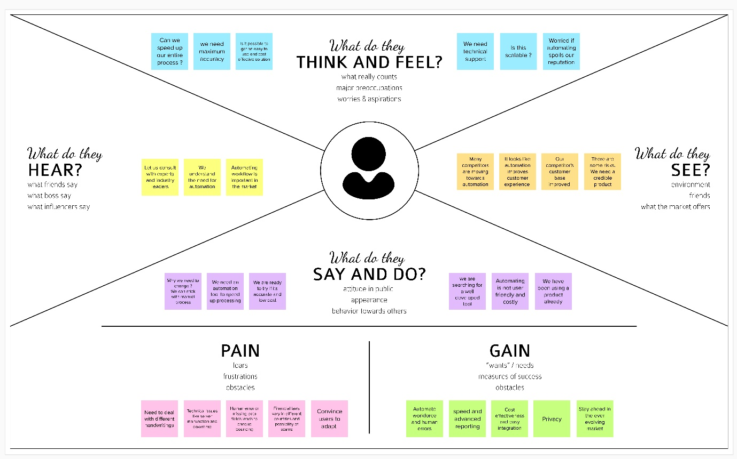

**3.2. IDEATION AND BRAINSTORMING**

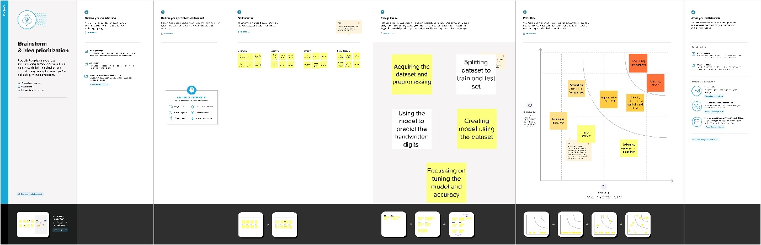

**3.3. PROPOSED SOLUTION**

|  |  |  |
| --- | --- | --- |
| **S. No** | **Parameter** | **Description** |
| 1. | Problem Statement | To develop a system that will identify the handwritten digit correctly |
| 2. | Idea / Solution Description | 1. Predict the digit using deep learning algorithms 2. Ensure the correct prediction of digit |
| 3. | Novelty / Uniqueness | 1. Predict the digits instantly 2. Recognizing digits irrespective of the varying handwriting styles |
| 4. | Social impact / Customer Satisfaction | Serves workers at postal offices and bank, where it can be used for mail sorting and check processing. Also helpful in data form entry. It will reduce the work load from workers and hence reduce stress |
| 5. | Business Model | 1. Collaboration with postal office and banks. And other corporations using database 2. Saves time and cost with manual labor 3. Bank check programming 4. Tax documentation |
| 6. | Scalability of the Solution | 1. Fine tuning the model aiming to produce more accurate results 2. Making it independent with less human intervention |

**3.4. PROBLEM SOLUTION FIT**

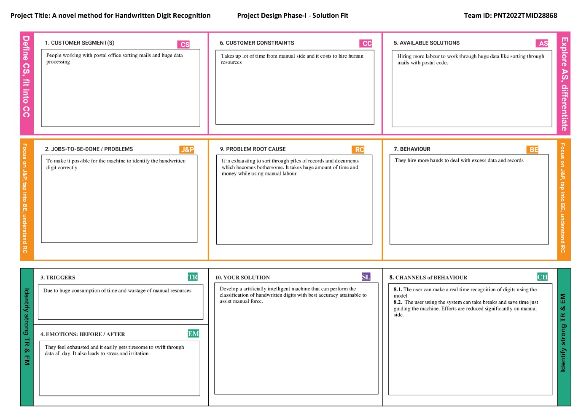

**4.0. REQUIREMENT ANALYSIS**

**4.1. FUNCTIONAL REQUIREMENTS**

|  |  |  |
| --- | --- | --- |
| **FR No.** | **Functional Requirement (Epic)** | **Sub Requirement (Story / Sub-Task)** |
| FR-1 | User Registration | Registration through Form  Registration through Gmail  Registration through LinkedIN |
| FR-2 | User Confirmation | Confirmation via Email  Confirmation via OTP |
| FR-3 | Login | Login using credentials |
| FR-4 | Upload Input | Upload image  Upload via on-screen |
| FR-5 | Train | Multiple inputs to train |
| FR-6 | Test | Test via fresh data |
| FR-7 | Maintenance | Handle all user data |
| FR-8 | Update | Update if any new feature available |

**4.2. NON-FUNCTIONAL REQUIREMENTS**

|  |  |  |
| --- | --- | --- |
| **FR No.** | **Non-Functional Requirement** | **Description** |
| NFR-1 | **Usability** | It will be easily accessible by the user. Simple and easy to understand |
| NFR-2 | **Security** | The data and input given by the user will be protected. Password-protected and only the particular user can alter their data |
| NFR-3 | **Reliability** | It is highly reliable and the accuracy can be increased with training |
| NFR-4 | **Performance** | Good performance with short time to run |
| NFR-5 | **Availability** | It is easily available on all platforms. Available on web |
| NFR-6 | **Scalability** | It is scalable and new features can be integrated. Multiple digits can be recognised at a time, real time recognition can be done |

**5. PROJECT DESIGN**

**5.1. DATA FLOW DIAGRAM**

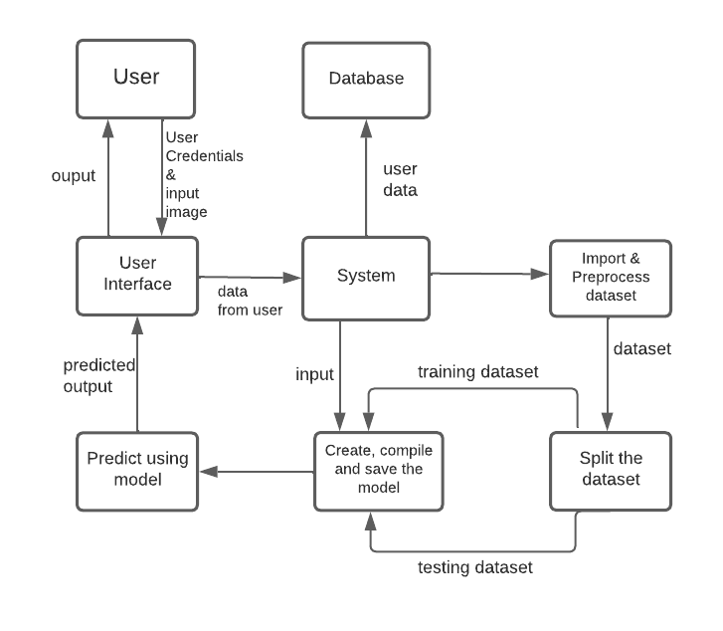

image

1. User Interface
2. Input from the user
3. System loads the dataset
4. Splitting into training and testing
5. CNN modelling
6. Output prediction
7. Display the output

**5.2. SOLUTION AND TECHNICAL ARCHITECTURE**

**Solution Architecture**

Handwritten Digit Recognition can be done with the help of the deep learning algorithm, Convolutional Neural Network (CNN) which works similar to that of the neurons in human brain. The MNIST dataset containing 70,000 images of handwritten digits is loaded and pre-processed. The dataset is split as training and testing set and then the CNN model is created and saved. The model is used for identifying the handwritten digit from the user.

The major steps involved in this.

1. Load the dataset
2. Splitting into training and testing
3. CNN modelling
   1. Convolution
   2. Pooling
   3. Fully connected
4. Output prediction

**Architecture Diagram**

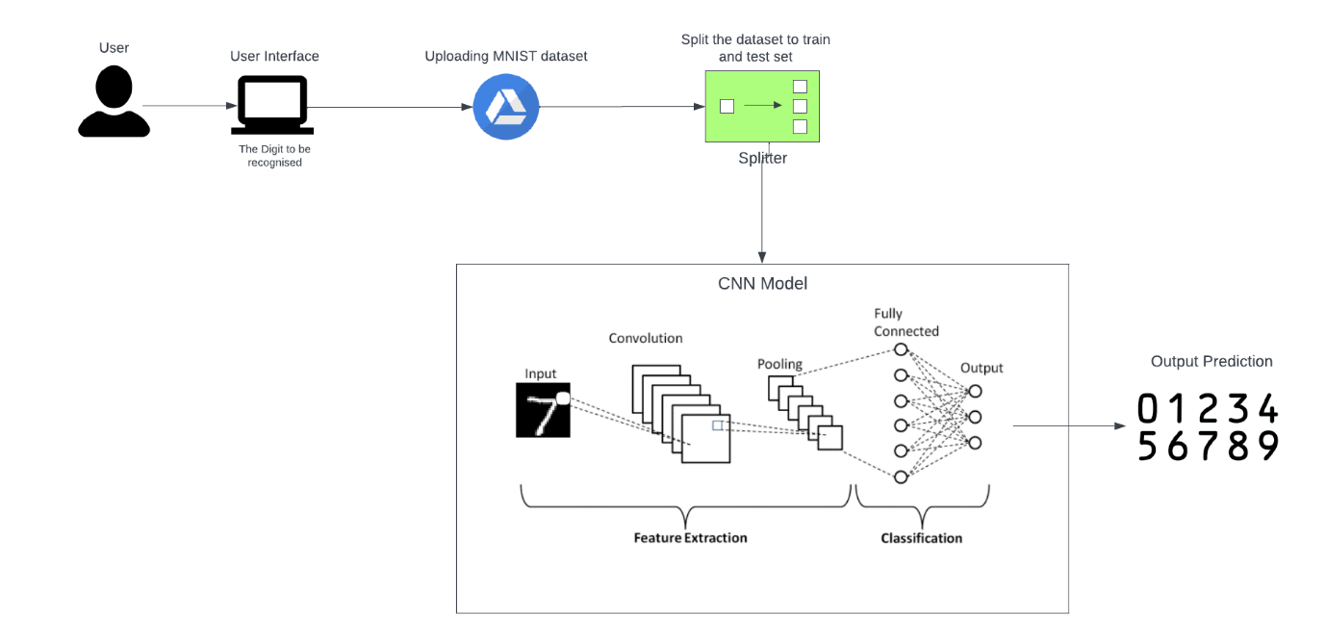

**Technical architecture**

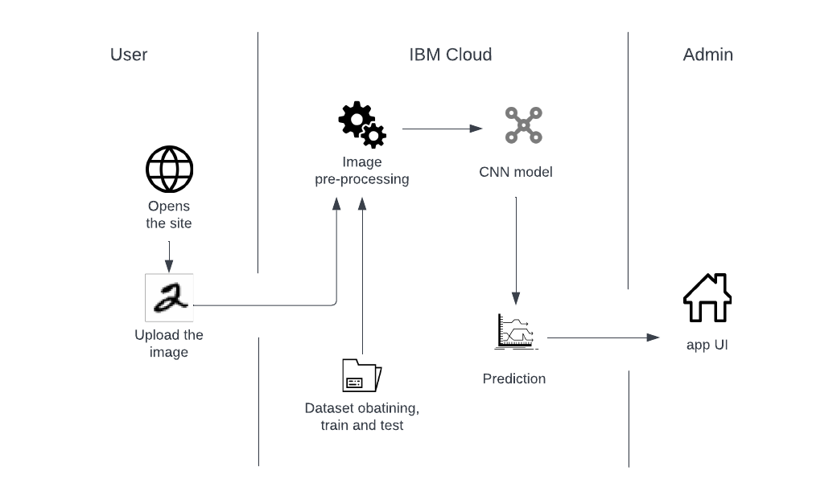

**Components & Technologies:**

|  |  |  |  |
| --- | --- | --- | --- |
| **S.No** | **Component** | **Description** | **Technology** |
|  | User Interface | Open the Web UI | HTML, CSS, JavaScript |
|  | Application Logic-1 | To download and process data | Python |
|  | Application Logic-2 | To train and deploy the model | IBM Watson ML service |
|  | Database | User data and inputs | MySQL, NoSQL, etc. |
|  | Cloud Database | Database Service on Cloud to store all the data | IBM DB2, IBM Cloudant etc. |
|  | File Storage | To store user data and the input digit images | IBM Block Storage or Other Storage Service or Local Filesystem |
|  | Machine Learning Model | Model to recognise the handwritten digits | Image  Recognition Model |
| **S.No** | **Component** | **Description** | **Technology** |
|  | Infrastructure (Server / Cloud) | Application Deployment on Local System / Cloud  Local Server Configuration:  Cloud Server Configuration | Local, Cloud Foundry, Kubernetes, etc. |

**Application Characteristics:**

| **S.No** | **Characteristics** | **Description** | **Technology** |
| --- | --- | --- | --- |
|  | Open-Source Frameworks | The handwritten digit dataset | MNIST dataset |
|  | Security Implementations | Only authorized user can access the data, users are authenticated with passwords | SHA-256, Encryptions, IAM Controls, OWASP etc. |
|  | Scalable Architecture | The model is highly scalable to see performance changes with design change | 3-tier architecture |
|  | Availability | The system will be available for the users when it is requested handling traffic well | Distributed servers |
|  | Performance | The response time is small and user gets their request executed in seconds | Cache |

**5.3. USER STORIES**

|  |  |  |  |  |  |  |
| --- | --- | --- | --- | --- | --- | --- |
| **USER**  **TYPE** | **FUNCTIONAL REQUIREMENT (EPIC)** | **USER STORY NUMBER** | **USER STORY/TASK** | **ACCEPTANCE CRITERIA** | **PRIORITY** | **RELEASE** |
| Customer | Registration | USN1 | I should register with my credentials like username, email and passwords as a customer | I can access my account via email | High | Sprint-1 |
|  | Verification | USN2 | As a customer I will verify my registration with email received | I can verify my registration through my email | High | Sprint-1 |
|  | Login | USN3 | I, as a customer, should login with my credentials | I can login the page | Low | Sprint-2 |
|  | Upload Input | USN4 | I will upload my input as an image or via on -screen mode | I can write the digit or upload the image | High | Sprint-2 |
|  | Train | USN5 | As a customer I will train the system thoroughly with proper and frequent inputs | I can upload proper images frequently to train the system | Medium | Sprint-3 |
|  | Test | USN6 | As a customer I will test the system periodically with new data to check the system accuracy | I can check he system accuracy with my fresh data | High | Sprint-3 |
| Administrator | Maintenance | USN7 | As an admin I will maintain the user data properly | I can handle the customer data | High | Sprint-4 |
|  | Update | USN8 | As an administrator I will check if I can make any effective updates on the system | I will update the system when it is required | Medium | Sprint-4 |

**6. PROJECT PLANNING & SCHEDULING**

**6.1. SPRINT PLANNING AND ESTIMATION**

|  |  |  |  |  |  |  |
| --- | --- | --- | --- | --- | --- | --- |
| **RELEASE** | **FUNCTIONAL REQUIREMENT (EPIC)** | **USER STORY NUMBER** | **USER STORY/TASK** | **PRIORITY** | **STORY POINTS** | **TEAM**  **MEMBERS** |
| Sprint-1 | Registration | USN1 | I should register with my credentials like username, email and passwords as a customer | High | 2 | Akshaya M  Arthima A |
| Sprint-1 | Verification | USN2 | As a customer I will verify my registration with email received | High | 2 | Sanjai M, Tharun Kumar L |
| Sprint-2 | Login | USN3 | I, as a customer, should login with my credentials | Low | 1 | Akshaya M  Arthima A |
| Sprint-2 | Upload Input | USN4 | I will upload my input as an image or via on -screen mode | High | 1 | Tharun Kumar L, Sanjai M |
| Sprint-3 | Train | USN5 | As a customer I will train the system thoroughly with proper and frequent inputs | Medium | 3 | Akshaya M, Arthima A, Sanjai M, Tharun Kumar L |
| Sprint-3 | Test | USN6 | As a customer I will test the system periodically with new data to check the system accuracy | High | 3 | Akshaya M, Arthima A, Sanjai M, Tharun Kumar L |
| Sprint-4 | Maintenance | USN7 | As an admin I will maintain the user data properly | High | 2 | Akshaya M, Arthima A, Sanjai M, Tharun Kumar L |
| Sprint-4 | Update | USN8 | As an administrator I will check if I can make any effective updates on the system | Medium | 3 | Akshaya M, Arthima A, Sanjai M, |

**6.2. SPRINT DELIVERY SCHEDULE**

| **Sprint** | **Total Story Points** | **Duration** | **Sprint Start Date** | **Sprint End Date (Planned)** | **Story Points Completed (as on Planned End Date)** | **Sprint Release Date (Actual)** |
| --- | --- | --- | --- | --- | --- | --- |
| Sprint-1 | 20 | 6 Days | 24 Oct 2022 | 31 Oct 2022 | 20 | 31 Oct 2022 |
| Sprint-2 | 20 | 6 Days | 31 Oct 2022 | 5 Nov 2022 | 20 | 5 Nov 2022 |
| Sprint-3 | 20 | 6 Days | 5 Nov 2022 | 12 Nov 2022 | 20 | 12 Nov 2022 |
| Sprint-4 | 20 | 6 Days | 12 Nov 2022 | 19 Nov 2022 | 20 | 19 Nov 2022 |

**6.3. REPORTS FROM JIRA**

**Velocity:**

Imagine we have a 6-day sprint duration, and the velocity of the team is 20 (points per sprint). Let’s calculate the team’s average velocity (AV) per iteration unit (story points per day)

**AV = *sprint duration / velocity***

**AV = 20/6 = 3.33**

**Burndown Chart:**

A burn down chart is a graphical representation of work left to do versus time. It is often used in agile software development methodologies such as Scrum. However, burn down charts can be applied to any project containing measurable progress over time.

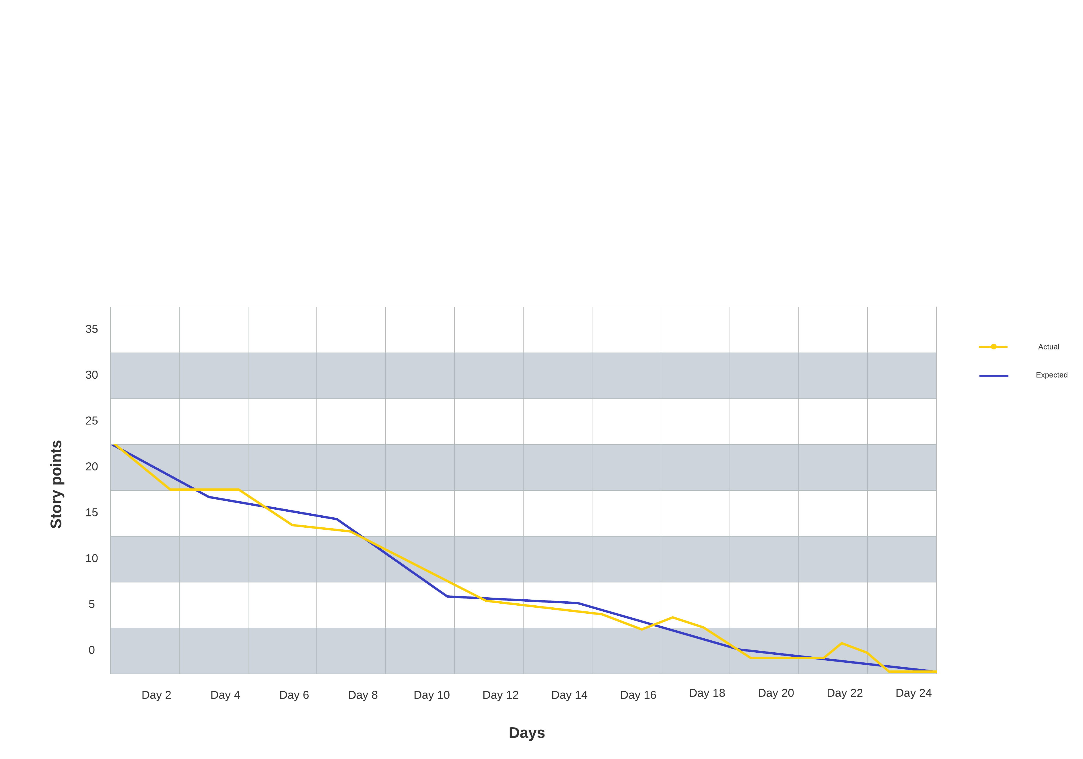

**7. CODING AND SOLUTIONING**

**7.1. FEATURE-1 MODEL BUILDING**

ML depends heavily on data, without data, it is impossible for a machine to learn. It is the most crucial aspect that makes algorithm training possible. In Machine Learning projects, we need a training data set. It is the actual data set used to train the model for performing various actions. TensorFlow already has MNIST Data set so there is no need to explicitly download or create Dataset. The MNSIT dataset contains ten classes: Digits from 0-9. Each digit is taken as a class. The required libraries are imported which are required for the model to run. The dataset for this model is imported from the Keras module. The data is split into train and test. Using the training dataset, the model is trained and the testing dataset is used to predict the results. Basically, the pixel values range from 0-255. The value of each image is stored is y_train. The model is built with convolutional, pooling and dense layers. The created model is then compiled and saved.

**7.2. FEATURE-2 WEB APP**

HTML, CSS and JavaScript are used to create the web pages for the front end. An html page that takes in image files as input using form and submits to back end is created. A flask app is created using python flask, where it receives the image files from the templates, html pages and the prediction operation is done over this image. Later the predicted output is sent to the result page.

**8 TESTING**

**8.1 TEST CASES**

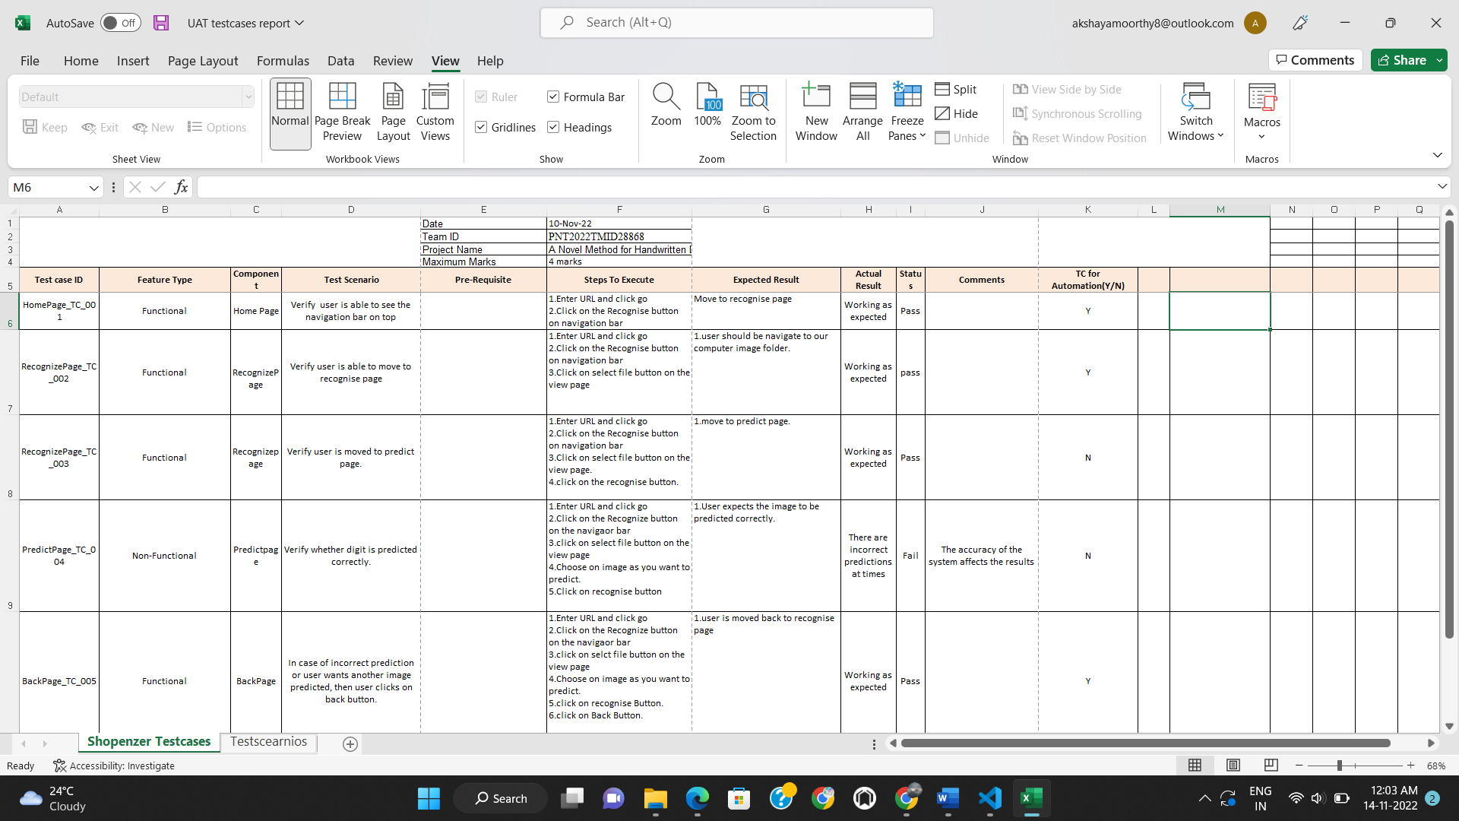

**8.2 USER ACCEPTANCE TEST**

**Defect Analysis**

This report shows the number of resolved or closed bugs at each severity level, and how they were resolved

|  |  |  |  |  |  |
| --- | --- | --- | --- | --- | --- |
| **Resolution** | **Severity 1** | **Severity 2** | **Severity 3** | **Severity 4** | **Subtotal** |
| By Design | 13 | 2 | 1 | 2 | 18 |
| Duplicate | 4 | 0 | 2 | 0 | 6 |
| External | 3 | 2 | 1 | 0 | 6 |
| Fixed | 12 | 3 | 2 | 17 | 34 |
| Not Reproduced | 0 | 2 | 0 | 0 | 2 |
| Skipped | 0 | 0 | 2 | 1 | 3 |
| Won't Fix | 0 | 3 | 4 | 1 | 8 |
| Totals | 32 | 12 | 13 | 21 | 77 |

**Test Case Analysis**

This report shows the number of test cases that have passed, failed, and untested

|  |  |  |  |  |
| --- | --- | --- | --- | --- |
| **Section** | **Total Cases** | **Not Tested** | **Fail** | **Pass** |
| Client Application | 37 | 0 | 0 | 37 |
| Image | 14 | 0 | 0 | 14 |
| Prediction | 5 | 0 | 2 | 3 |
| **Section** | **Total Cases** | **Not Tested** | **Fail** | **Pass** |
| Exception Reporting | 7 | 0 | 0 | 7 |
| Final Report Output | 4 | 0 | 0 | 4 |
| Version Control | 2 | 0 | 0 | 2 |

**9. RESULTS**

**9.1 PERFORMANCE METRICS**

|  |  |  |  |
| --- | --- | --- | --- |
| **S.No.** | **Parameter** | **Values** | **Screenshot** |
|  | Model Summary |  |  |
|  | Accuracy | Training Accuracy –  74.94  Validation Accuracy -  87.23000 |  |

**10. ADVANTAGES & DISADVANTEGES**

ADVANTAGES:

* It saves times for arranging and sorting huge amount of data
* Only requires far less physical space than the storage of the physical

copies.

* ‌Recognising multiple digits on a single frame using sequential model in

Keras.

* Data storage, for an example, there are many files, contracts and some personal records that contains some handwritten digits.
* It reduces human effort and labour cost
* This can be used for sorting through mail by postal code

DISADVANTAGES

* The system build is complex and holds difficulty
* The handwriting of every individual varies which proves to be a challenge for the system to predict
* Possible unemployment of labour that is typical of technology growth
* The accuracy is not guarantees and there are risk of errors

**11. CONCLUSION**

Handwritten digit recognition has immense applications in the field of medical, banking, student management, and taxation process etc. Many classifiers like KNN, SVM, and CNN are used to identify the digit from the handwritten image. Here we've used CNN for implementation. Convolutional Neural Network gets trained from the real-time data and makes the model very simple by reducing the number of variables and gives relevant accuracy. MNIST dataset consist of handwritten numbers from 0-9 and it is a standard dataset used to find performance of classifiers.

Results of HDR is improved a lot by using CNN classifier but it can be improved further in terms of complexity, duration of execution and accuracy of results by making combination of classifiers or using some additional algorithm with it. More accurate results can be established with more convolution layers and more number of hidden neurons. It can completely abolish the need for typing. Digit recognition is an excellent prototype problem for learning about neural networks and it gives a great way to develop more advanced techniques of deep learning.

**12. FUTURE SCOPE**

In future, different architectures of CNN, namely, hybrid CNN, viz., CNN-RNN and CNN-HMM models, and domain-specific recognition systems, can be investigated. Evolutionary algorithms can be explored for optimizing CNN learning parameters, namely, the number of layers, learning rate and kernel sizes of convolutional filters. The future development of the applications based on algorithms of deep and machine learning is practically boundless.

In the future, we can work on a denser or hybrid algorithm than the current set of algorithms with more manifold data to achieve the solutions to many problems. In future, the application of these algorithms lies from the public to high-level authorities, as from the differentiation of the algorithms above and with future development we can attain high-level functioning applications which can be used in the classified or government agencies as well as for the common people. Currently only the digits are recognized. In future the all the characters in all the language can be predicted with high accuracy rate.

**13. APPENDIX**

**Source code**

The necessary libraries are imported.

import keras

import tensorflow

from keras.datasets import mnist

from keras.layers import Dense, Dropout, Flatten

from keras.layers import Conv2D, MaxPooling2D

from keras import backend as K

from tensorflow.keras.utils import to_categorical

import matplotlib.pyplot as plt

from tensorflow.keras.models import Sequential

from tensorflow.keras.layers import Conv2D

from tensorflow.keras.layers import MaxPooling2D

from tensorflow.keras.layers import Dense

from tensorflow.keras.layers import Flatten

from tensorflow.keras.optimizers import SGD

The MNIST dataset is downloaded from the keras library and the data is analyzed.

# the data, split between train and test sets

(x_train,y_train),(x_test,y_test)=mnist.load_data()

print(x_train.shape,y_train.shape)

print(x_test.shape,y_test.shape)

x_train[0]

The data is pre-processed and reshaped

#Preprocess the data

num_classes=10

x_train=x_train.reshape(x_train.shape[0],28,28,1)

x_test=x_test.reshape(x_test.shape[0],28,28,1)

input_shape = (28,28,1)

Applying one-hot encoding. The class vectors are converted to binary class matrices.

#Convert class vectors to binary class matrices

y_train=keras.utils.to_categorical(y_train,num_classes)

y_test=keras.utils.to_categorical(y_test,num_classes)

x_train=x_train.astype('float32')

x_test=x_test.astype('float32')

x_train=x_train/255

x_test=x_test/255

print('x_train shape:',x_train.shape)

print(x_train.shape[0],'train samples')

The CNN model is created. The activation function is Rectified linear unit(ReLU). The pooling layers, dense layers are added and flattened.

#Create the Model

batch_size=128

num_classes=10

epochs=20

model = Sequential()

model.add(Conv2D(32, kernel_size=(3,3),activation='relu',input_shape=input_shape))

model.add(Conv2D(64,(3,3),activation='relu'))

model.add(MaxPooling2D(pool_size=(2,2)))

model.add(Dropout(0.25))

model.add(Flatten())

model.add(Dense(64,activation='relu'))

model.add(Dropout(0.5))

model.add(Dense(num_classes,activation='softmax'))

The model is then compiled

model.compile(loss=keras.losses.categorical_crossentropy,

optimizer=keras.optimizers.

Adadelta(),metrics=['accuracy'])

The model is trained

hist = model.fit(x_train, y_train,batch_size=20,epochs=5,verbose=1,validation_data=(x_test, y_test))

Observing the metrics and testing the model

metrics = model.evaluate(x_test, y_test, verbose=0)

print("Metrics(Loss and Accuracy):")

print(metrics)

prediction = model.predict(x_test[:4])

print(prediction)

The model is saved and then tested. A sample image is given in to test the saved model. The image is reshaped and then predicted.

model.save('digit_classifier.h5')

from keras.utils.image_utils import img_to_array

from tensorflow.keras.models import load_model

model = load_model('/content/digit_classifier.h5')

from PIL import Image

import numpy as np

img = Image.open('/content/sample.png').convert("L")

img = img.resize((28,28))

im2arr = np.array(img)

im2arr = im2arr.reshape(1,28,28,1)

#display the image

import matplotlib.pyplot as plt

plt.imshow(img)

#predict the image

y_predict = model.predict(im2arr)

print(np.argmax(y_predict[0]))

The pages to display the home and recognise page with navigation bar.

HDR front end.html

<html>

    <head>

        <style>

            body {

              background-image: url('https://cdn.pixabay.com/photo/2020/09/23/03/54/background-5594879_1280.jpg');

              margin: 0;

              font-family: 'Times New Roman', Times, serif, Helvetica, sans-serif;

            }

            .topnav {

              overflow: hidden;

              background-color: rgb(255, 255, 255);

            }

            .topnav a {

              float: left;

              color: #480557;

              text-align: center;

              padding: 14px 16px;

              text-decoration: none;

              font-size: 17px;

            }

            .topnav a:hover {

              background-color: rgb(57, 55, 55);

              color: rgb(250, 248, 248);

            }

            .topnav a.active {

              background-color: #f8e406;

              color: rgb(19, 19, 19);

            }

            p{

                text-align: center;

                background-color: rgb(8, 0, 0);

                margin-left: 25%;

                margin-right: 25%;

                margin-top: 5%;

                font-family:'Times New Roman', Times, serif;

                color:aliceblue;

                font-size: large;

            }

            </style>

    </head>

    <body>

        <div class="topnav">

            <a class="active" href="#home">Home</a>

            <a href="recognise.html">Recognise</a>

        </div>

        <p style="font-size:larger">Handwritten Digit Recognition</p>

        <p>Handwriting recognition is one of the compelling research works going on because every

            individual in this world has their own style of writing. It is the capability of the computer to identify and understand handwritten digits or characters

             automatically. Because of the progress in the field of science and technology, everything is being digitalized to reduce human effort. Hence, there comes

             a need for handwritten digit recognition in many real-time applications. MNIST data set is widely used for this recognition process and it has 70000

             handwritten digits. We use Artificial neural networks to train these images and build a deep learning model. Web application is created where the user

             can upload an image of a handwritten digit. this image is analyzed by the model and the detected result is returned on to UI</p>

    </body>

</html>

The recognise page where the user can upload the image for prediction

recognise.html

<html>

    <head>

        <meta charset="UTF-8">

        <meta http-equiv="X-UA-Compatible" content="IE=edge" />

        <title>Digit Recognition</title>

        <style>

            body {

              background-image: url('https://img.freepik.com/premium-vector/falling-colorful-messy-numbers-math-study-concept-with-flying-digits-fascinating-back-school-mathematics-banner-white-background-falling-numbers-vector-illustration_174187-2929.jpg?w=2000');

              margin: 0;

              font-family: 'Times New Roman', Times, serif, Helvetica, sans-serif;

              height: 100%;

              width: 100%;

            }

            h1 {

                display: block;

                font-size: 3.5em;

                margin-top: 5.4em;

                margin-bottom: 0em;

                margin-left: 50%;

                margin-right: 0;

                font-weight: bold;

            }

            .button {

                border:#e5b9f3;

                color: rgb(56, 1, 69);

                padding: 15px 32px;

                text-align: center;

                text-decoration: none;

                display: inline-block;

                font-size: 16px;

                margin: 4px 2px;

                cursor: pointer;

                }

            .button1 {

                background-color: #b6e6f0;

                margin-top: 5.4em;

                margin-left: 56%;

                margin-right: 0;

                border: black;

            }

            .button2 {

                background-color: #b6e6f0;

                margin-top: 5.5em;

                margin-left: 55%;

                margin-right: 0;

                border: black;

            }

        </style>

        <script>

            function view() {

                frame.src=URL.createObjectURL(event.target.files[0]);

            }

            $('#submit').click(function(){

                $.ajax({

                    url: 'app.py',

                    type: 'POST',

                })

            })

            var input = document.getElementById('image');

            var infoArea = document.getElementById('frame');

            input.addEventListener('change', showFileName);

            function showFileName(event) {

                var input = event.srcElement;

                var fileName = input.files[0].name;

                infoArea.textContent = 'File name: ' + fileName;

            }

        </script>

        <script src="https://kit.fontawesome.com/b3aed9cb07.js" crossorigin="anonymous"></script>

        <script src="https://code.jquery.com/jquery-3.3.1.slim.min.js" integrity="sha384-q8i/X+965DzO0rT7abK41JStQIAqVgRVzpbzo5smXKp4YfRvH+8abtTE1Pi6jizo" crossorigin="anonymous"></script>

        <script src="https://cdnjs.cloudflare.com/ajax/libs/popper.js/1.14.7/umd/popper.min.js" integrity="sha384-UO2eT0CpHqdSJQ6hJty5KVphtPhzWj9WO1clHTMGa3JDZwrnQq4sF86dIHNDz0W1" crossorigin="anonymous"></script>

        <script src="https://stackpath.bootstrapcdn.com/bootstrap/4.3.1/js/bootstrap.min.js" integrity="sha384-JjSmVgyd0p3pXB1rRibZUAYoIIy6OrQ6VrjIEaFf/nJGzIxFDsf4x0xIM+B07jRM" crossorigin="anonymous"></script>

        <script src="https://cdn.jsdelivr.net/npm/@tensorflow/tfjs@latest"></script>

        <script src="https://ajax.googleis.com/ajax/libs/jquery/3.1.0/jquery.min.js"></script>

    </head>

    <body>

        <h1 style = "color: rgb(2, 60, 0)">Digit Recognition

        <br>

        <br>

        <form action="/predict" method="POST" enctype="multipart/form-data">

        <input id="image" type="file" name="image" accept="image/png, image/jpeg" onchange="view()"><br><br>

        <img id="frame" type="submit" src="" width="100px" height="100px"/>

        <input type="submit" value="Recognise" class="button button2"/>

    </h1>

        </form>

    </body>

</html>

The page where the predicted output is displayed

predict.html

<!DOCTYPE html>

<html lang="en">

<head>

    <meta charset="UTF-8">

    <meta http-equiv="X-UA-Compatible" content="IE=edge" />

    <title>Prediction</title>

</head>

<style>

    body{

     background-image: url('https://img.freepik.com/premium-vector/falling-colorful-messy-numbers-math-study-concept-with-flying-digits-fascinating-back-school-mathematics-banner-white-background-falling-numbers-vector-illustration_174187-2929.jpg?w=2000');

     background-repeat: no-repeat;

     height: 100%;

     width: 100%

    }

    .button{

        border:#e5b9f3;

        color: rgb(56, 1, 69);

        padding: 15px 32px;

        text-align: center;

        text-decoration: none;

        display: inline-block;

        font-size: 16px;

        margin-left:45%;

        cursor: pointer;

    }

    #pred{

        text-align: center;

        font-family: 'Times New Roman', Times, serif;

        font-size: 40px;

        margin: 0 auto;

        padding: 3% 5%;

        padding-top: 15%;

        color: rgb(0, 10, 80);

    }

</style>

<body>

        <p id="pred">PREDICTION : {{ num }}</p>

        <p>

        <a href="recognise.html">

            <button data-inline="True" class="button">Back</button>

        </a>

        </p>

</body>

</html>

The flask app.py python code to calculate the prediction value from processing the image uploaded by the user

app.py

import os

import numpy as np

from flask import Flask, render_template, request

import tensorflow as tf

from PIL import Image

from werkzeug.utils import secure_filename

UPLOAD_FOLDER = 'C:\Users\AKSHAYA\Pictures\static\images'

app = Flask(__name__)

app.config['UPLOAD_FOLDER'] = UPLOAD_FOLDER

@app.route('/')

def index():

    return render_template('recognise.html')

model = tf.keras.models.load_model("digit_classifier.h5")

@app.route('/predict', methods = ['GET','POST'])

def upload_image_file():

    if request.method == 'POST':

        imagefile = request.files['image']

        filename = secure_filename(imagefile.filename)

        imagefile.save(os.path.join(app.config['UPLOAD_FOLDER'], filename))

        path_img = os.path.join(UPLOAD_FOLDER, filename)

        img = Image.open(path_img).convert("L")

        img = img.resize((28,28))

        im2arr = np.array(img)

        im2arr = im2arr.reshape(1,28,28,1)

        y_pred = model.predict(im2arr)

        return render_template('predict.html', num = str(y_pred))

if __name__ == '__main__' :

    app.run(host='0.0.0.0', port=8000, debug=True)

**Github**

<https://github.com/IBM-EPBL/IBM-Project-11561-1659334515>

**Demo link**